**SQL CODING CHALLENGE – CRIME MANAGEMENT**

* **Crime Management Database Setup**

1. Creating a Database

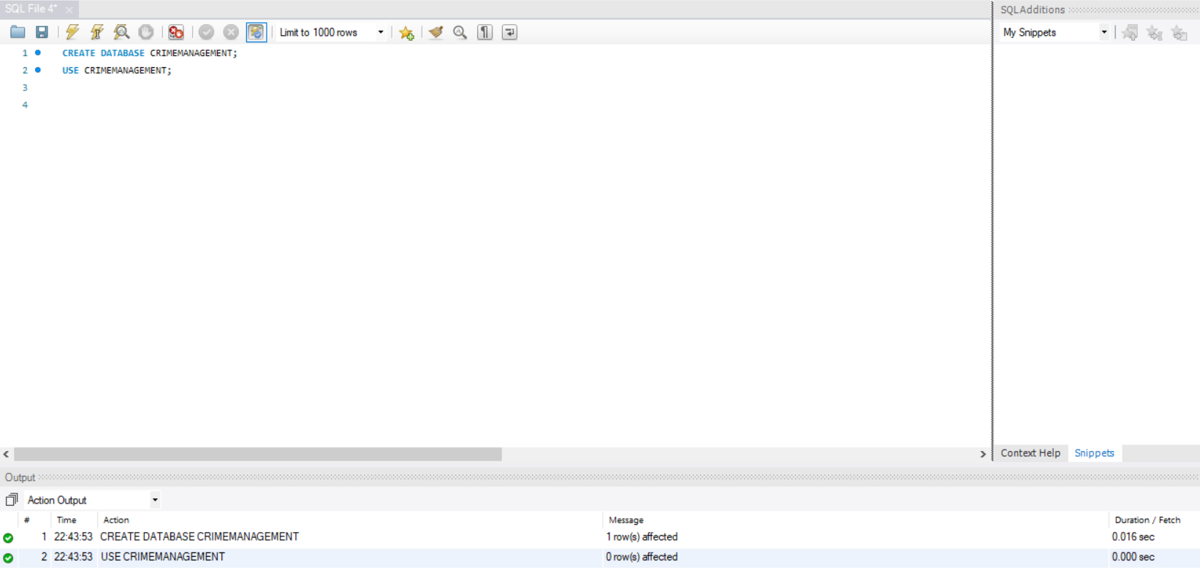

1. Creating Tables for crime management, including the **Crime**, **Victim**, and **Suspect** tables.

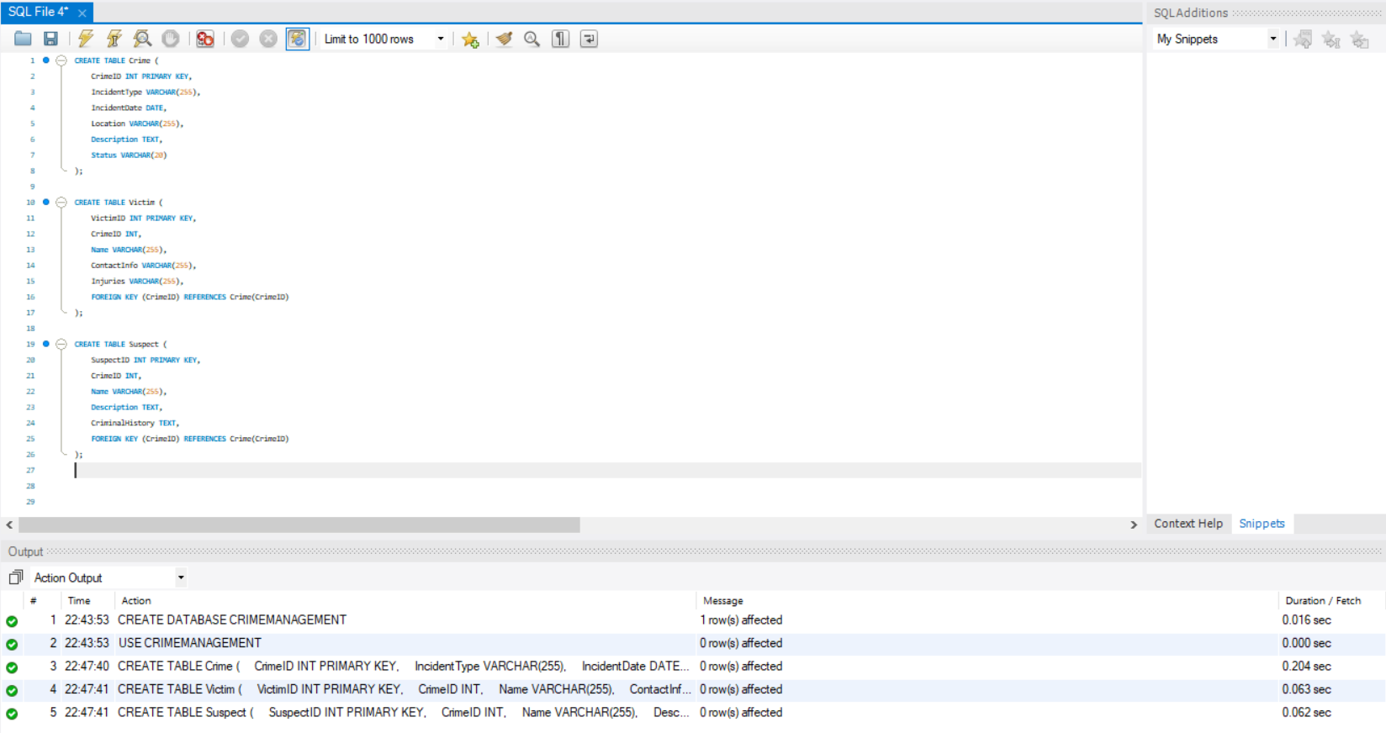

1. Sample Data Insertion - **Crime**, **Victim**, and **Suspect** tables with sample data.

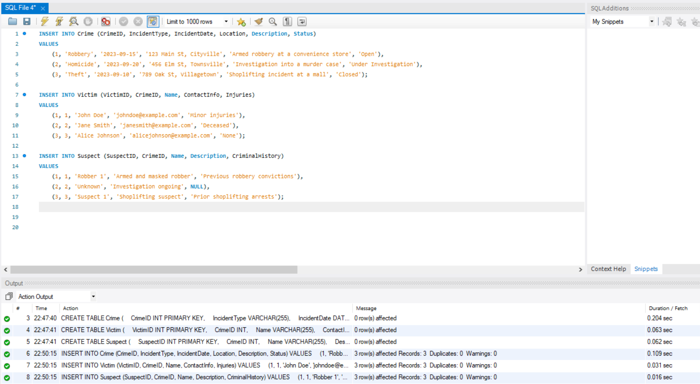

* **SQL Queries for Analysis**

1. **Select all open incidents**

SELECT * FROM Crime WHERE Status = 'Open';

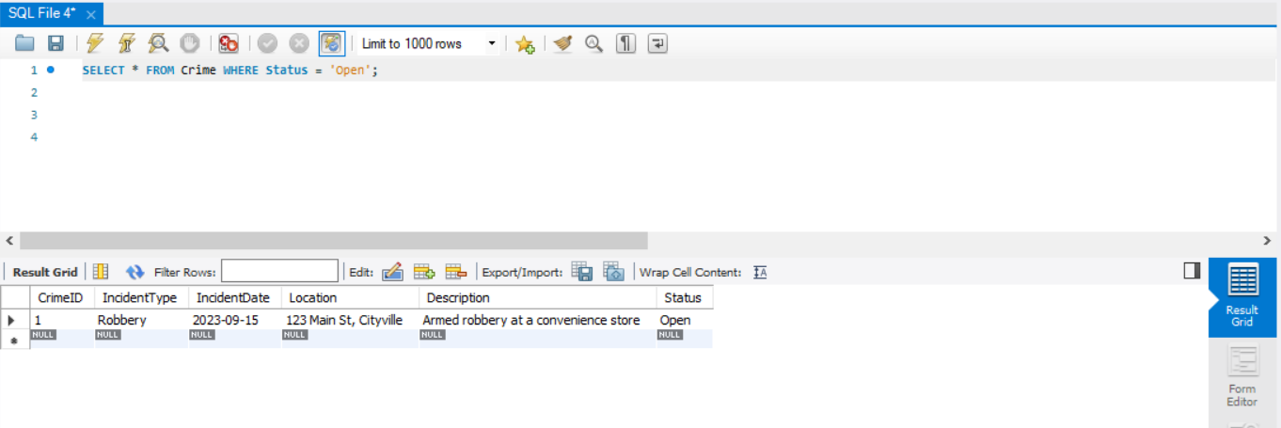

1. **Find the total number of incidents**

SELECT COUNT(*) AS TotalIncidents FROM Crime;

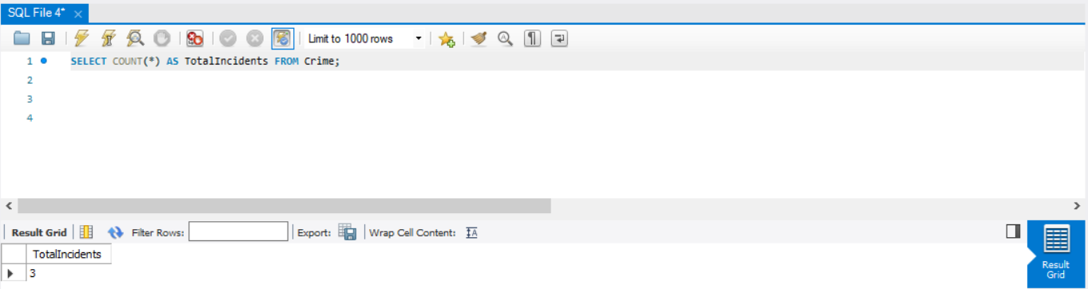

1. **List all unique incident types**

SELECT DISTINCT IncidentType FROM Crime;

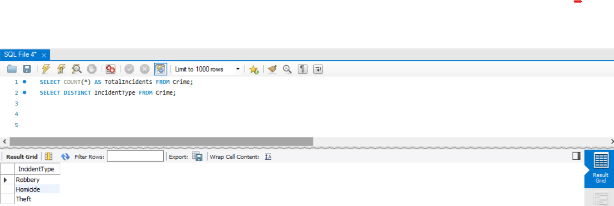

1. **Retrieve incidents that occurred between '2023-09-01' and '2023-09-10'**

SELECT * FROM Crime WHERE IncidentDate BETWEEN '2023-09-01' AND '2023-09-10';

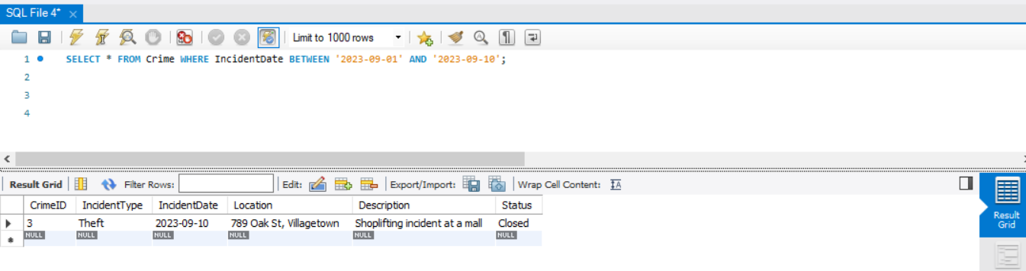

1. **List persons involved in incidents in descending order of age**

I first created an Individuals table to store personal details such as names and ages. This table was then linked to both the Victim and Suspect tables, allowing us to retrieve relevant information based on age.

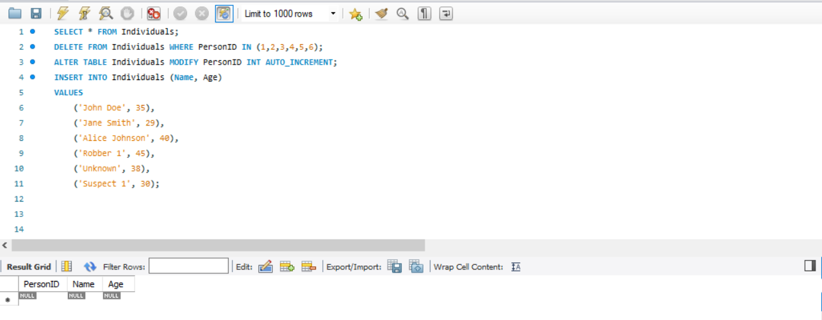

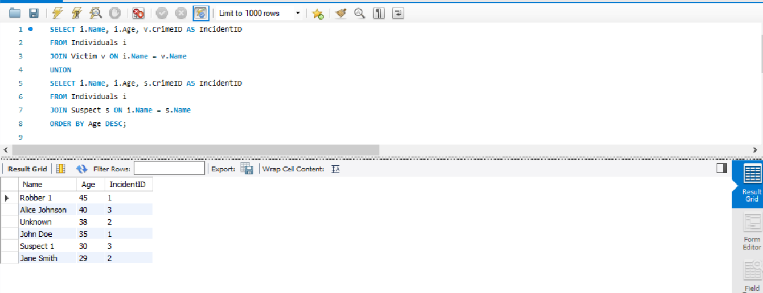

1. **Find the average age of persons involved in incidents**

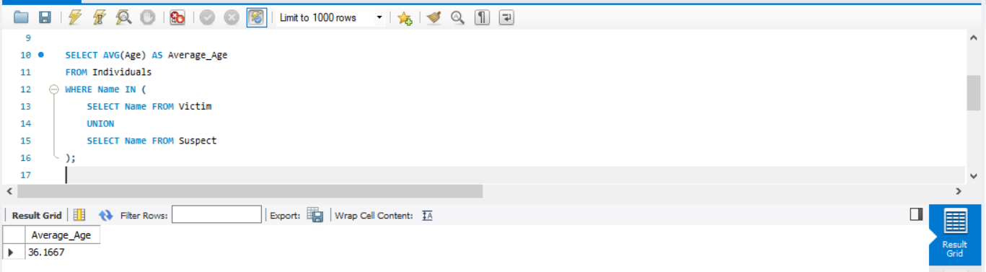

**7. List incident types and their counts, only for open cases**

SELECT IncidentType, COUNT(*) AS Count

FROM Crime

WHERE Status = 'Open'

GROUP BY IncidentType;

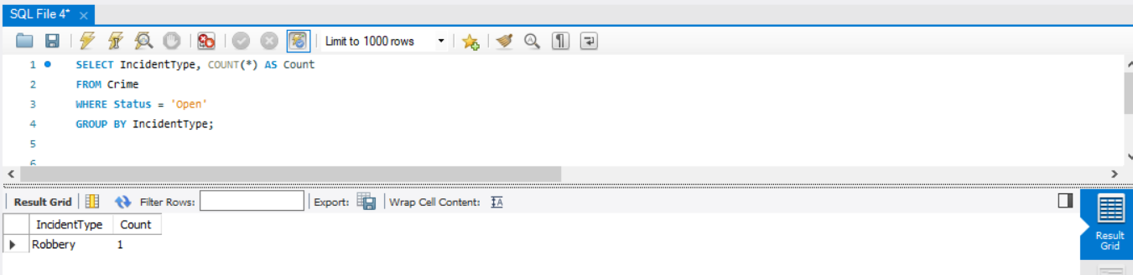

**8. Find persons with names containing 'Doe'**

SELECT * FROM Victim WHERE Name LIKE '%Doe%';

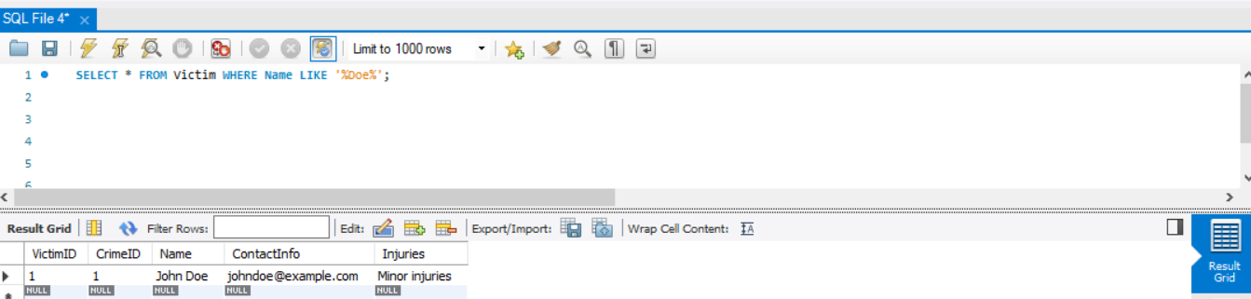

**9. Retrieve the names of persons involved in open and closed cases**

SELECT Name FROM Victim

JOIN Crime ON Victim.CrimeID = Crime.CrimeID

WHERE Crime.Status IN ('Open', 'Closed')

UNION

SELECT Name FROM Suspect

JOIN Crime ON Suspect.CrimeID = Crime.CrimeID

WHERE Crime.Status IN ('Open', 'Closed');

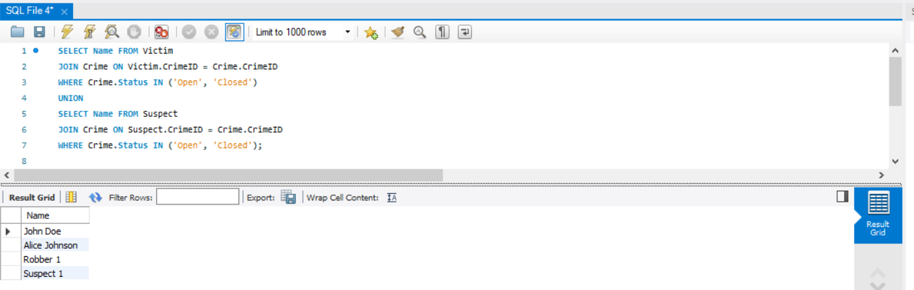

**10. List incident types where there are persons aged 30 or 35 involved**

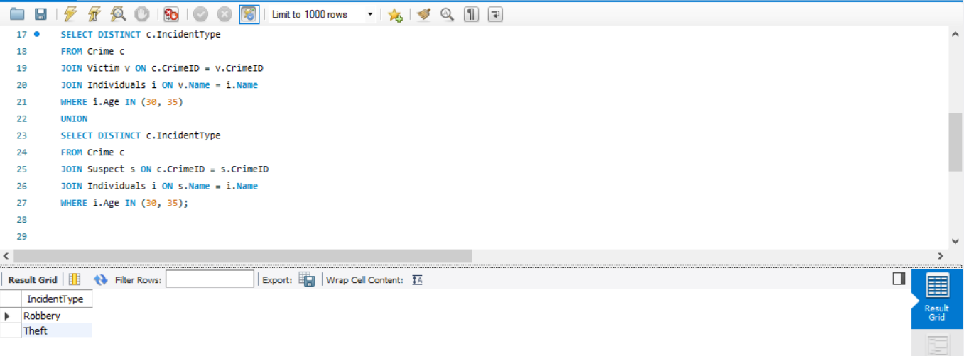

**11. Find persons involved in incidents of the same type as 'Robbery'**

SELECT Name FROM Victim

JOIN Crime ON Victim.CrimeID = Crime.CrimeID

WHERE Crime.IncidentType = 'Robbery'

UNION

SELECT Name FROM Suspect

JOIN Crime ON Suspect.CrimeID = Crime.CrimeID

WHERE Crime.IncidentType = 'Robbery';

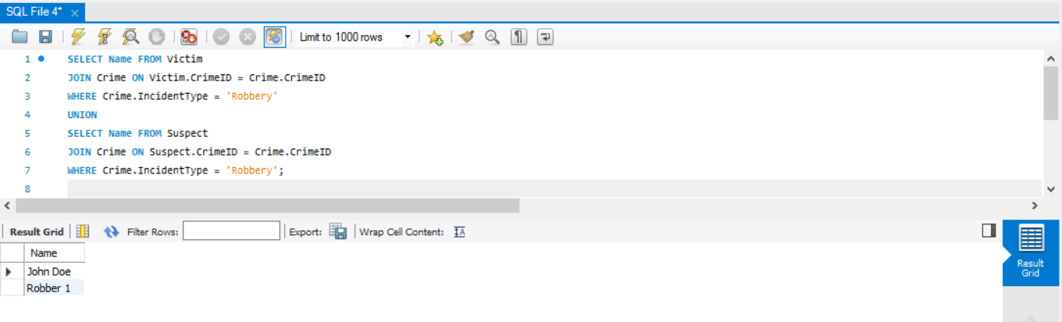

**12. List incident types with more than one open case**

SELECT IncidentType, COUNT(*) AS Count

FROM Crime

WHERE Status = 'Open'

GROUP BY IncidentType

HAVING COUNT(*) > 1;

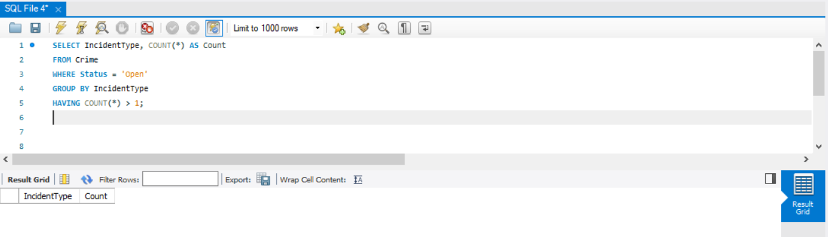

**13. List all incidents with suspects whose names also appear as victims**

SELECT DISTINCT C.*

FROM Crime C

JOIN Victim V ON C.CrimeID = V.CrimeID

JOIN Suspect S ON C.CrimeID = S.CrimeID

WHERE V.Name = S.Name;

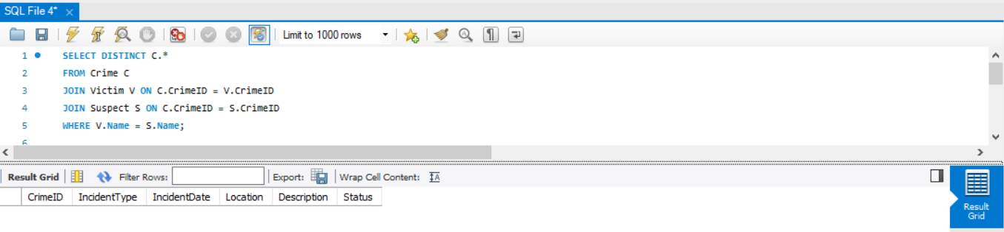

**14. Retrieve all incidents along with victim and suspect details**

SELECT C.*, V.Name AS VictimName, S.Name AS SuspectName

FROM Crime C

LEFT JOIN Victim V ON C.CrimeID = V.CrimeID

LEFT JOIN Suspect S ON C.CrimeID = S.CrimeID;

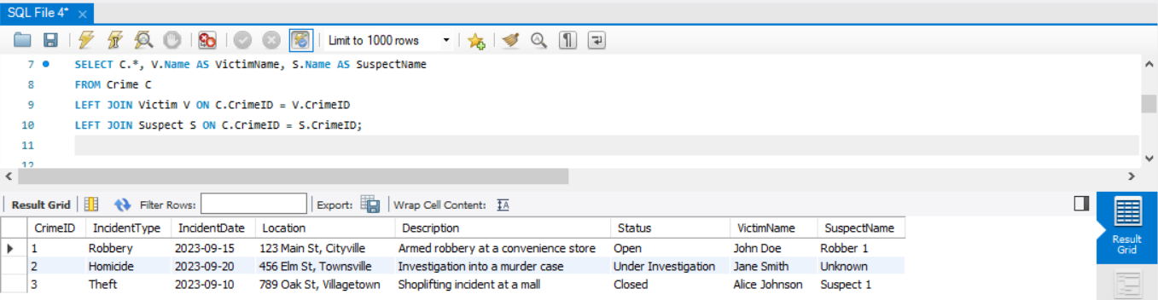

**15. Find incidents where the suspect is older than any victim**

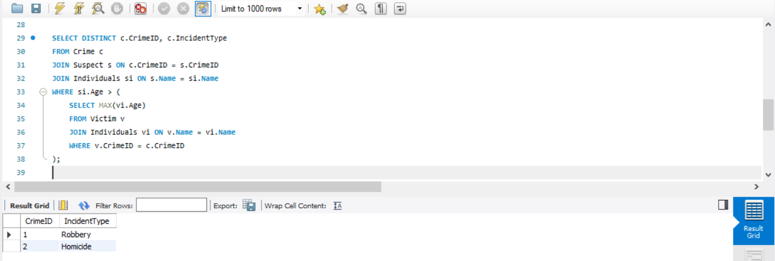

**16. Find suspects involved in multiple incidents**

SELECT Name, COUNT(*) AS IncidentCount

FROM Suspect

GROUP BY Name

HAVING COUNT(*) > 1;

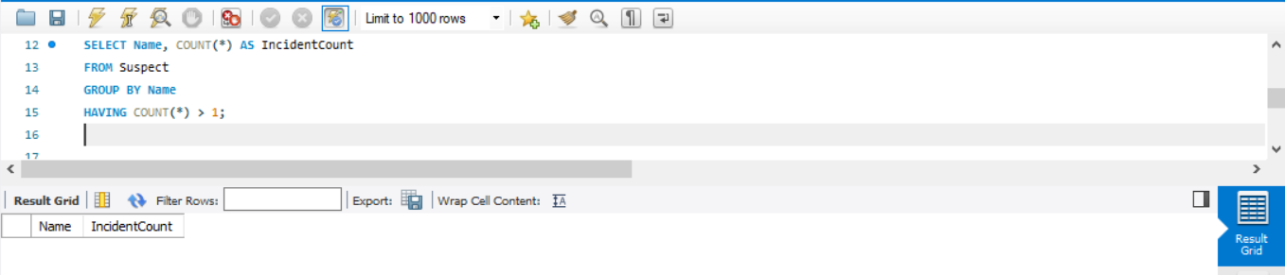

**17. List incidents with no suspects involved**

SELECT C.*

FROM Crime C

LEFT JOIN Suspect S ON C.CrimeID = S.CrimeID

WHERE S.SuspectID IS NULL;



**18. List all cases where at least one incident is 'Homicide' and all other incidents are 'Robbery'**

SELECT *

FROM Crime

WHERE IncidentType = 'Homicide'

AND NOT EXISTS (

SELECT 1 FROM Crime WHERE IncidentType != 'Robbery'

);

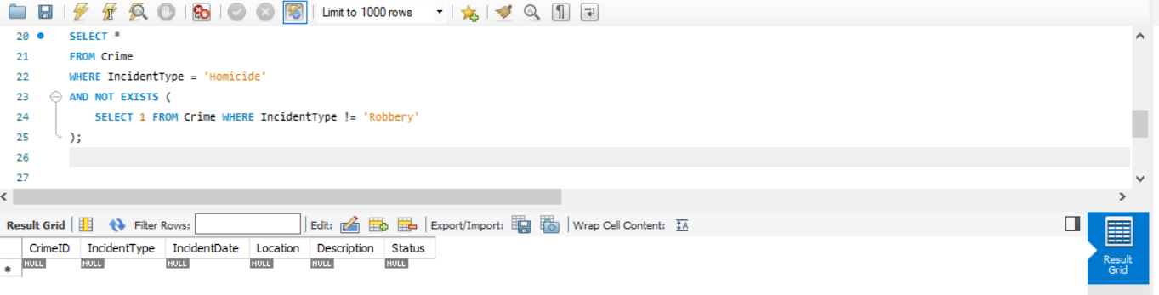

**19. Retrieve all incidents and the associated suspects, showing 'No Suspect' if none**

SELECT C.CrimeID, C.IncidentType, COALESCE(S.Name, 'No Suspect') AS SuspectName

FROM Crime C

LEFT JOIN Suspect S ON C.CrimeID = S.CrimeID;

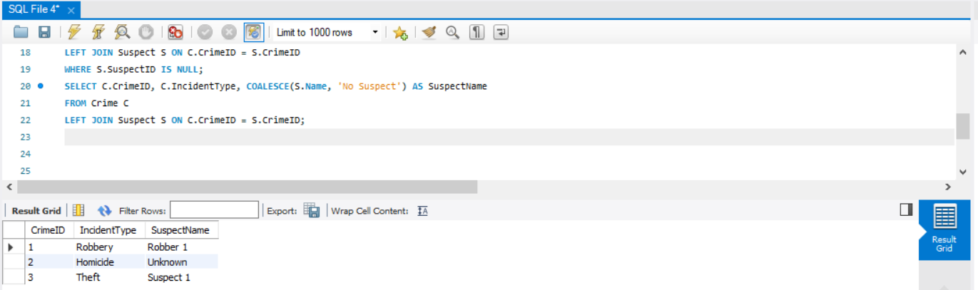

**20. List all suspects involved in incidents of type 'Robbery' or 'Assault'**

SELECT DISTINCT S.*

FROM Suspect S

JOIN Crime C ON S.CrimeID = C.CrimeID

WHERE C.IncidentType IN ('Robbery', 'Assault');

